**21.AWS-EFS & FSX**

After creating EFS go to the EC2 and click on Network Interface there you will see the created EFS.

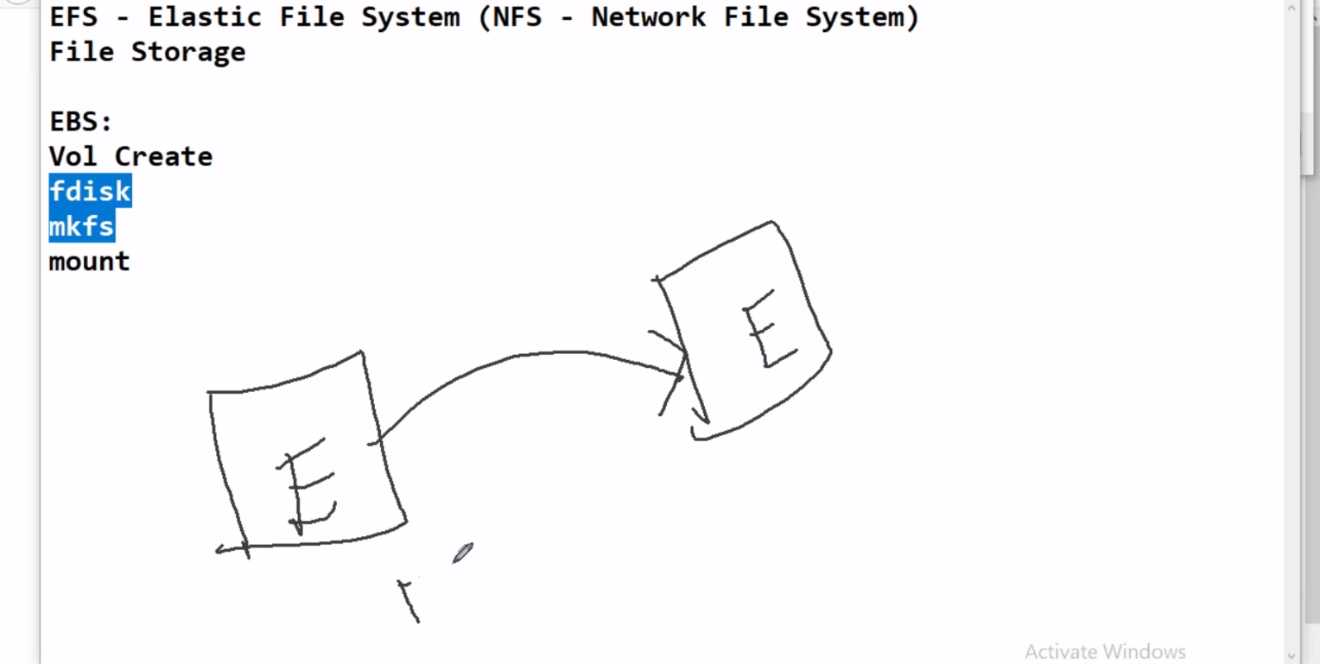

--- unlike EBS we don’t need to fallow those steps we can directly mount EFS to instance.

**EFS creating**

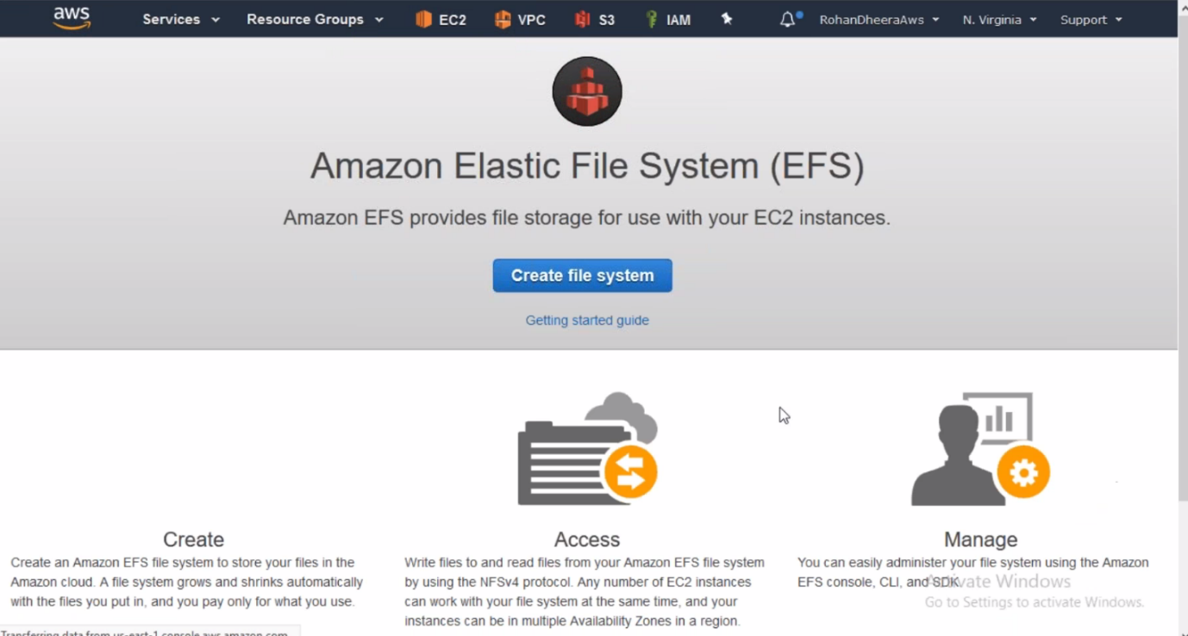

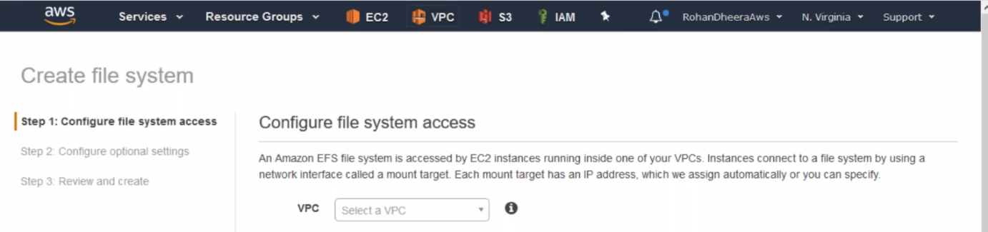

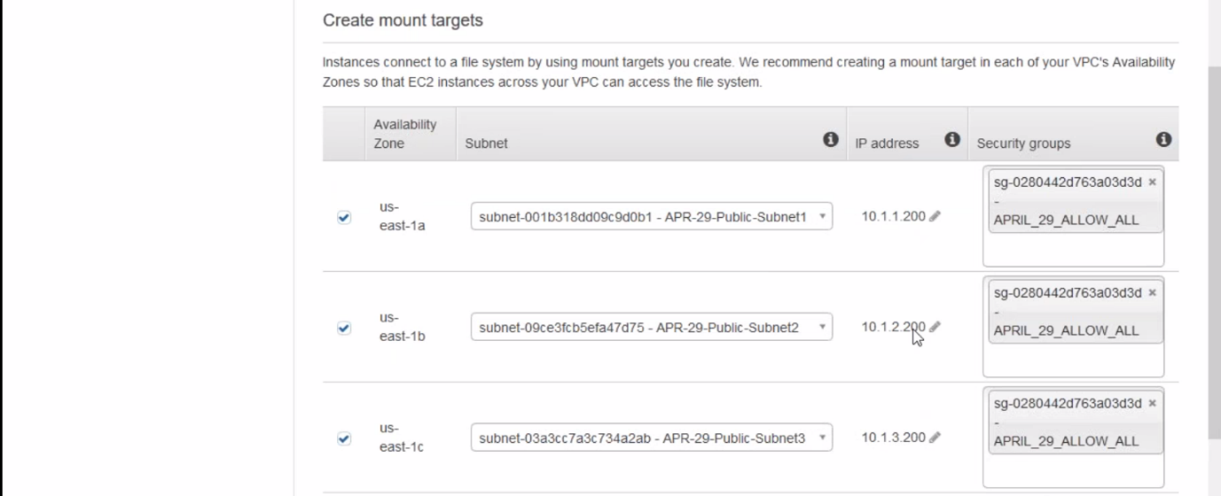

--- if you don’t mention IP address here it will take random IP addresses.

--- EFS uses this IP Address.

--- here we are creating EFS and we mentioning which IP address should connected to 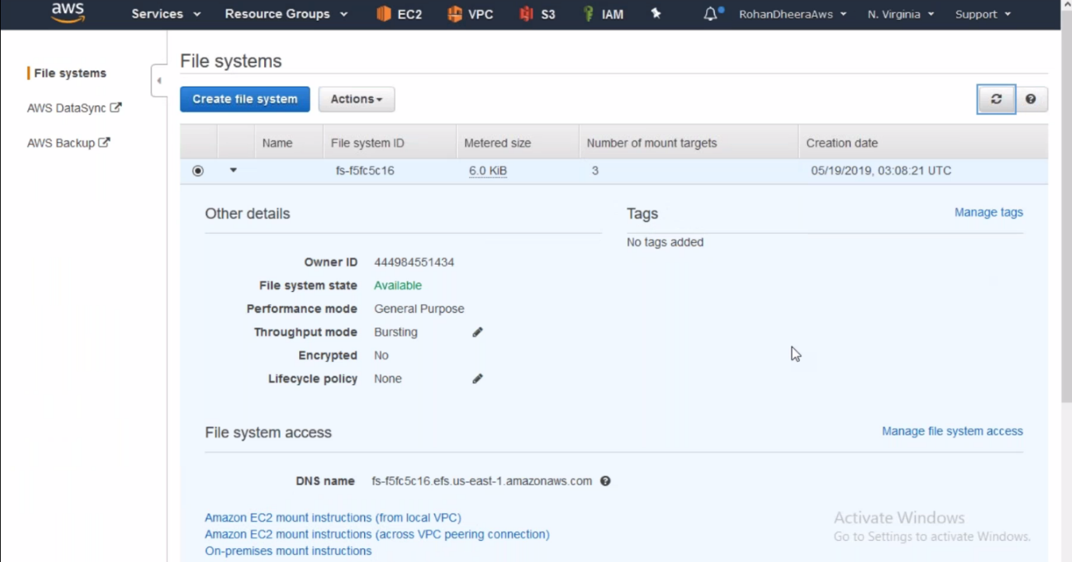the EFS.

--- Leave the remaining the click on create a file system.

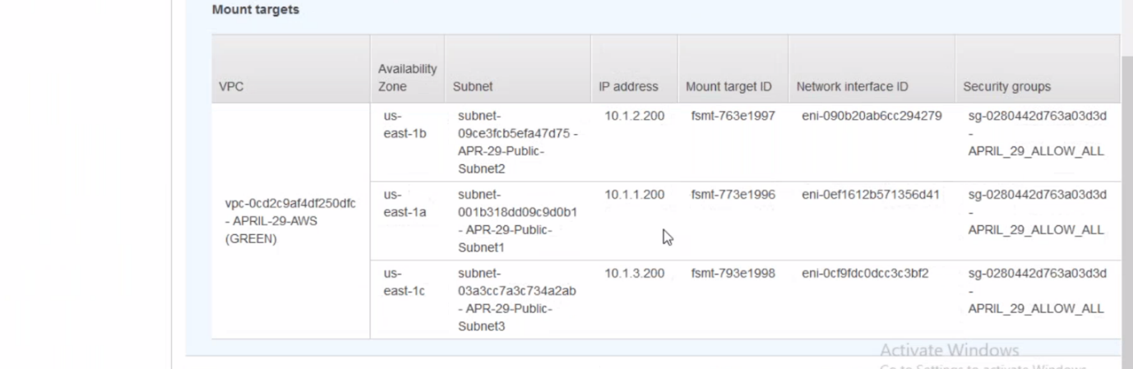

--- files system qualified domain name = DNS name

**Creating a folder and mounting the EFS to that folder**

You want to mount the EFS you need to install NFS but in case you are using Amazon LINUX no need to install NFS

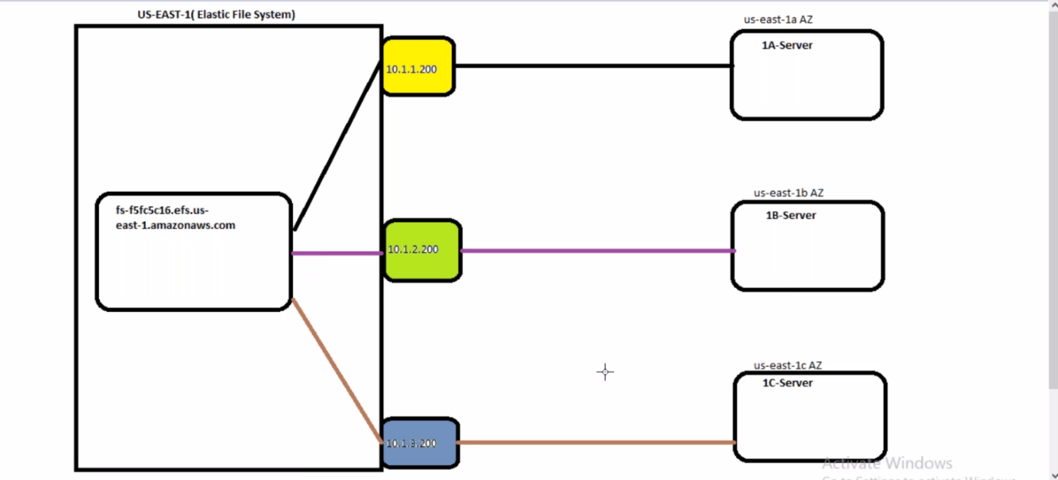

We don’t need to do routing and the 1A,1B,1C Servers are automatically connected to that IP address

Now launch the instance using above subnets and IP address.

Even you are in different region and IP address but we all connected to the same EFS storage in the backend. If you put one file in the EFS that file will be visible to all servers which are connected to that EFS.

Three ways we can mount EFS to folder

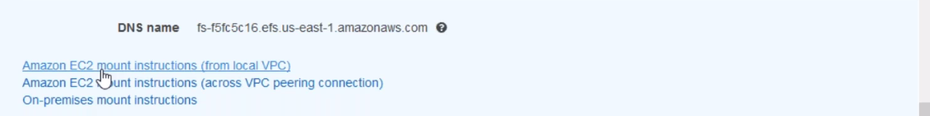

--- need VPN for on-premises

--- **df –h** – the no of mount available in the server.

--- **mkdir 1A-FOLDER** - create a folder(1A-FOLDER) we need to mount the storage to this folder.

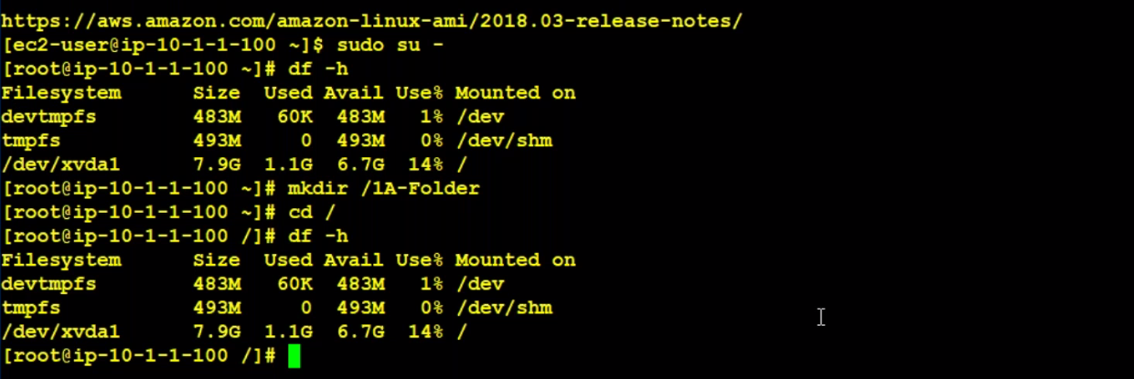

**Mounting process in EFS**

--- click on Amazon EC2 mount instructions.

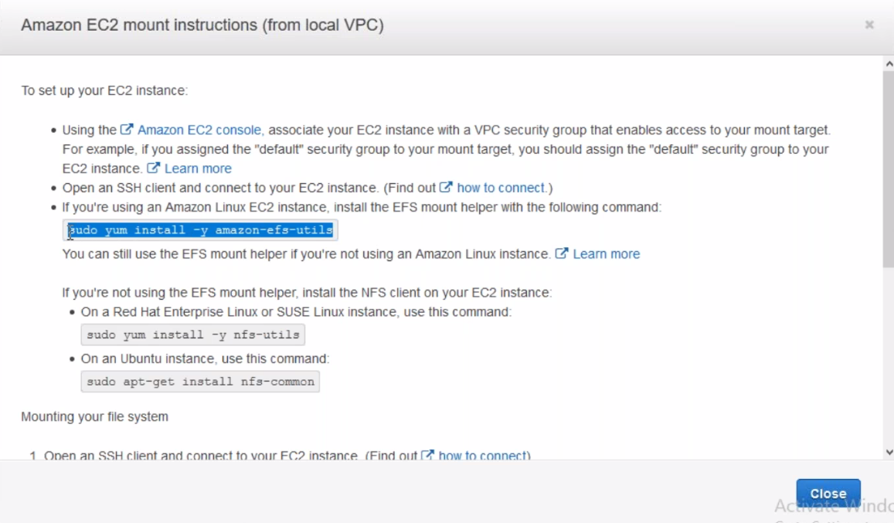

--- Fallow amazon EC2 mount instruction (from local vpc) which is present at the EFS fallow the instruction

--- **sudo yum install -y amazon-efs-utils**

**--- sudo mount -t nfs4 -o nfsvers=4.1,rsize=1048576,wsize=1048576,hard,timeo=600,retrans=2,noresvport fs-1fe5319f.efs.us-east-1.amazonaws.com:/ /1A-FOLDER – storage being mounted to the 1A-FOLDER.**

**--- there is no limit for the EFS storage, we can use as much as storage you like. Need to pay for the used storage.**

**--- mount – use this command to get the data of EFS connected IP address, mounted region, EFS DNS name…. Etc.**

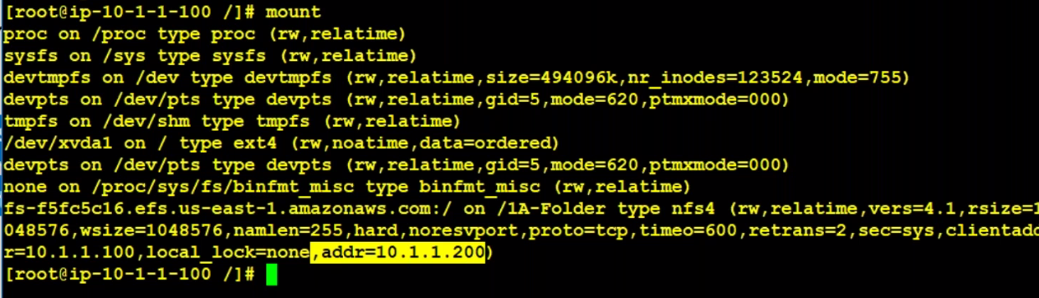

**--- you must be in root folder.**

**--- you crated a file on EFS storage that file will visible all there server. Even you connected from multiple availability zones, created file will be visible to all servers.**

**--- do the same in remaining 2 servers like create filer and mount the folder.**

**FSTAB**

The data don’t stored in EFS in case the server is restarted or rebooted, need’s to mention the folder information in fstab.

--- nano /etc/fstab

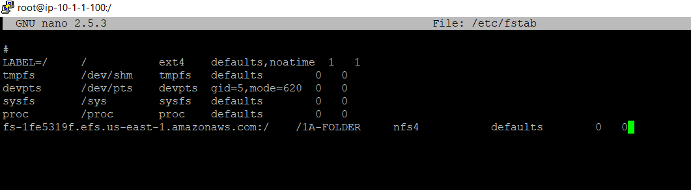

--- DNS host name

**VPC peering for EFS**

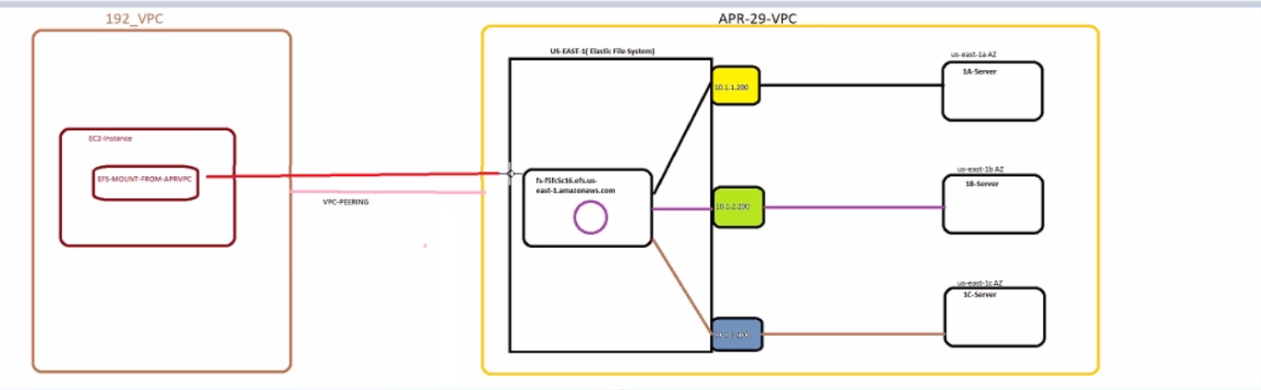

--- Here I am going to deploy a machine in IP 192.168.1.100

--- create VPC peering connection from APRIL(EFS) TO 192.168.1.100

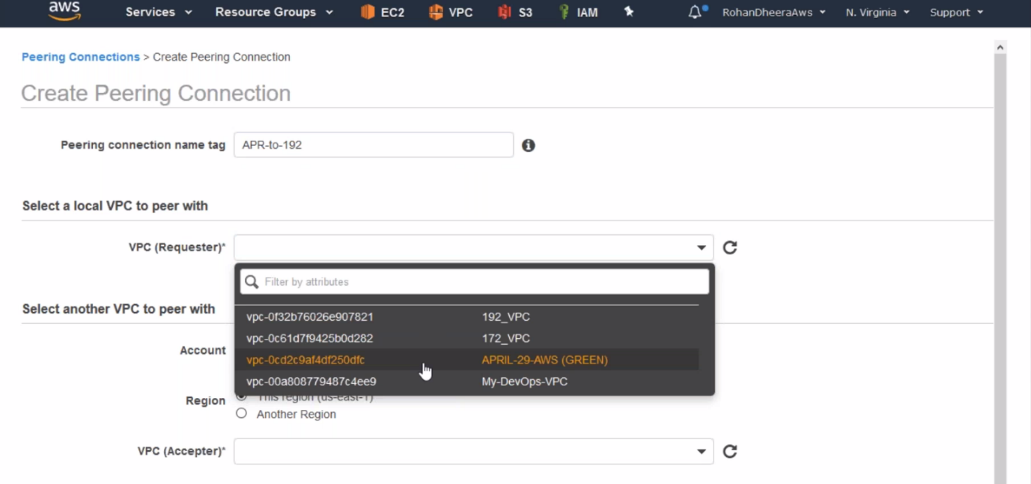

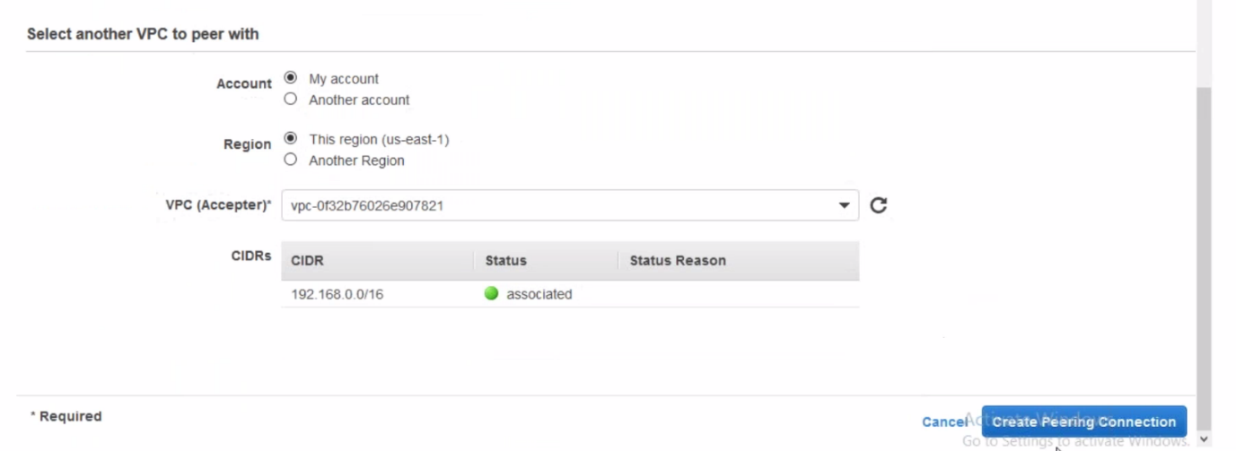

--- accept the pending request

--- routing table editing.

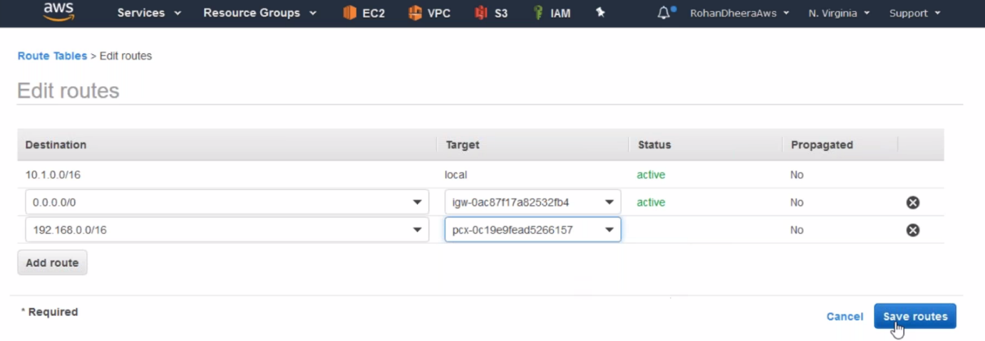

**--- login in to the server and create a folder**

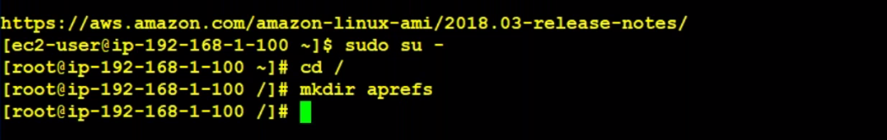

**--- EFS mounting process.**

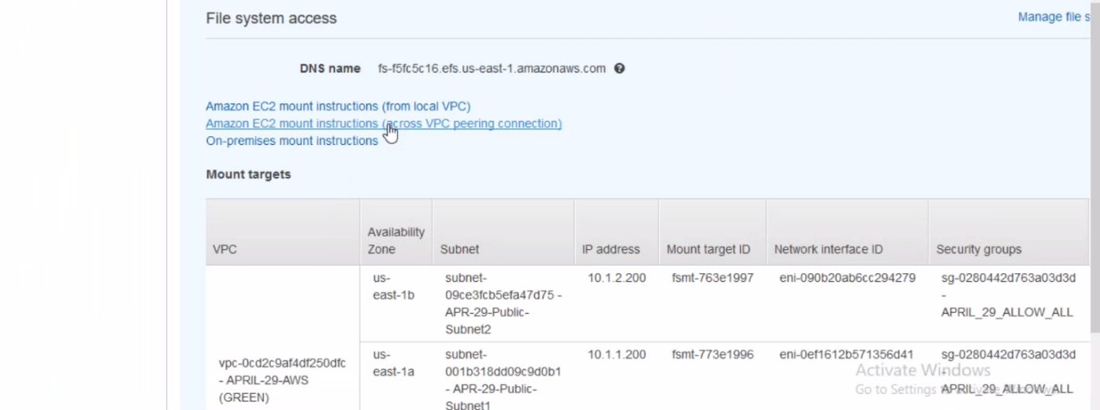

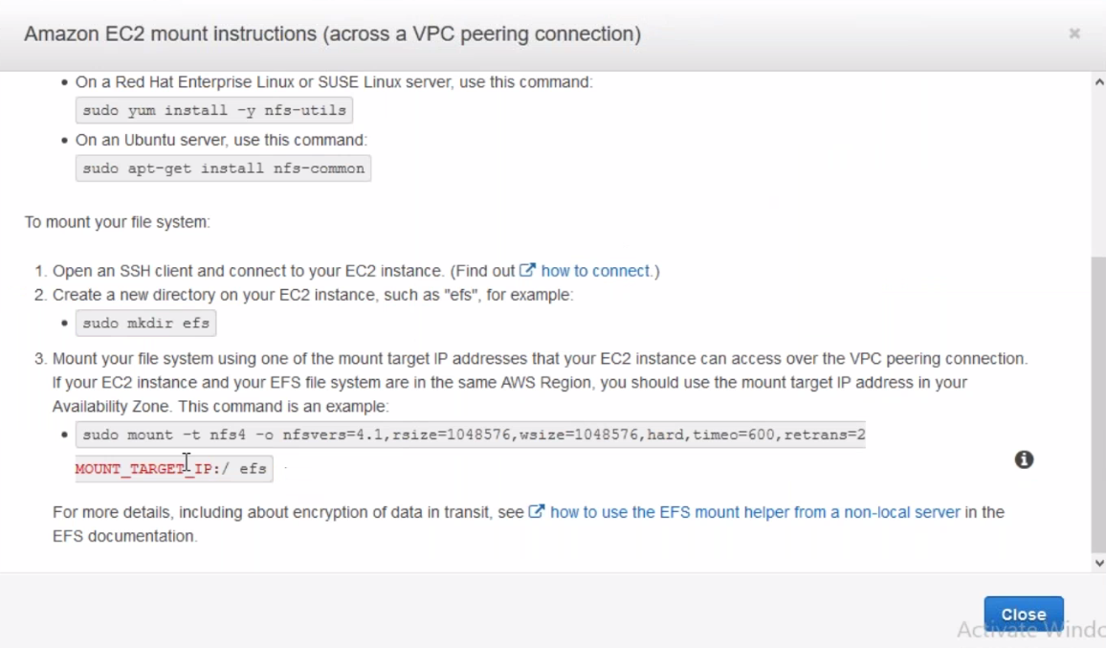

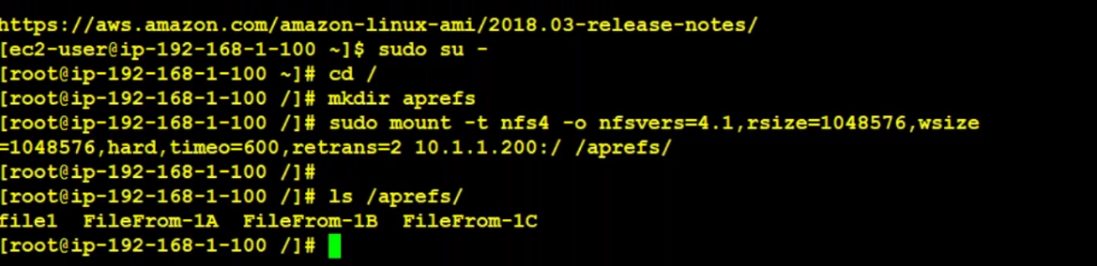

**---**

**--- sudo mount -t nfs4 -o nfsvers=4.1,rsize=1048576,wsize=1048576,hard,timeo=600,retrans=2,noresvport 10.1.2.200:/ /Folder10 – we can mount EFS STORAGE by using ip address (1A-SERVER 🡪 2ND EFS ip address)**

**--- don’t mount the storage using IP address, AWS recommended to use name.**

**--- here I am mounting using 1A-SERVER IP address**

**In Jenkins multi master (EFS)**

**---** If the servers rebooted, needs to remount again so you don’t want to remount again. Fallow the below command.